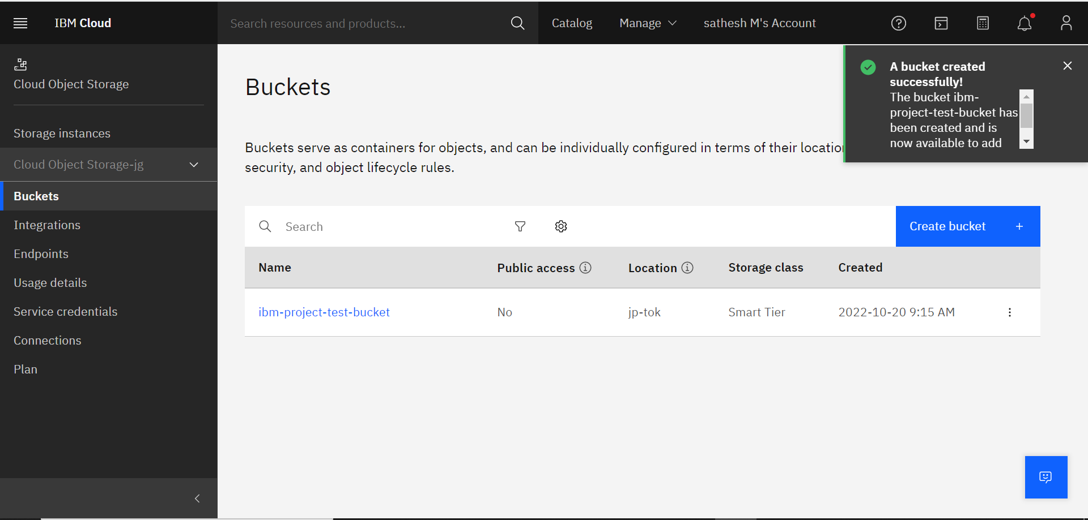
1.Create a Bucket in IBM object storage

